Doxygen Fork

Background
I have a little trouble generating automatic documentation for my PHP projects. phpDocumentor is dead. Doxygen doesn’t produce the documents the way I want.
I also have problems generating documentation for projects in other programming languages. JSDoc is fine, but it’d be great if it’s somehow integrated with the other documentation, have the same look and feel as the “parent” project (e.g., CSF JavaScripts inside CSF), which usually means it should be generated by the same documentation generator. Microsoft’s C# comments are too cumbersome, I like the old JavaDoc way.
I want UML documentation! Doxygen can create some UML-like stuff, but I want to generate UML automatically and these can be imported into Visio, Rose, Poseidon, or any other tool supporting XMI.
I want version control! Some of my projects are version controlled using Subversion. There must be a way to fetch these information automatically (like listing the people that has contributed to a particular function).
I want multiple language support.
I want language filter support, like MSDN documentation.
I want OS/platform/whatever filter support.
I want bugtracking support, using Subversion keywords is a must but I haven’t yet decided which bugtracking tool to support.
I want multiple versions support (also version filter), so I can cramp all documentation for all versions in one documentation.
I want pretty interface for all generated output!!! This is the most important. Also themeable/templatable output.
I also want pretty GUI, either Windows or Web-based.
I want neat, clean code, documented, and not reinventing the wheel. Use as much already available source as possible.
I want online features, like “notes”, like PHP’s. And also Wiki-related stuff. Maybe also blog stuff.
I want interoperability with Wiki (which one? I guess there’s something called InterWiki).
I want ease of use (damn important alright).
I want integration. I can put generated documentation inside other stuff, either embedded or linked. I can also put other stuff inside documentation (most notably tutorials/handwritten documentation, etc.)
I want extensive linking features. I want to link to other stuff, and I want other stuff to link to it. In GaulDong, I want to separate between GaulDong, individual GaulDong modules, CSF. In CSF, I want to separate CSF libraries, PEAR, other external libraries, individual CSF modules, etc. Yet when I open GaulDong documentation everything is available to me (even handwritten docs or the ones generated by other documentation tools).
I want to use and/or extend open standards. XML is preferred for almost everything.
I want multilanguage support. I want multilanguage support directly in the source code (how?)
I use UTF-8 only.
Combine programming languages if required, but only for the input language. For example, to parse a PHP file, we can use Reflection API, or the Tokenizer, which removes the requirement for a parser (and it’s quicker). Its output can then be processed later.
I want Test-Driven Development support. It should recognize tests and even asserts and can generate some kind of requirements specification documents.
I want Topic Map output (err…)

Goals
- One suite, different “flavors” (i.e. support for several programming languages), and a lot of subcomponents (preferably outsourced as much as possible)
- Uses a superset of programming language features instead of subset
- Supported programming languages: PHP 5 / PHP 4, Delphi, JavaScript, C++, C# (Visual Basic and Ruby is also on the waiting list)
- Supported target formats: JavaScript+DOM HTML, Microsoft HTML Help (CHM). DocBook XML, PDF, Microsoft Word is also on the waiting list.
- Pretty, interactive output for both HTML and CHM. Mimic MSDN for guide.
- Pretty, robust GUI (I’m thinking of .NET…)
- Language-independent self-contained templates, using graphics and stylesheets. Is it possible to have cross-output-format templates? (HTML with CHM is not that difficult, but how about HTML and PDF?). Each template is configurable, and can support several flavors. Convert phpDocumentor templates if possible.
- Multilanguage support (also in source code). Character set aware of course, input can be anything, but output will always be UTF-8.
- Distributed maintenance of modules. Obviously, Dimitri van Heesch will be maintaining doxygen, I hope the project won’t die. I will be maintaining its core (continuously merging changes from official doxygen) and most of the modules.
- Extensive integration, linking and embedding for subprojects, external documentation, etc.
- Ease of everything. Ease of use is #1. Easy to extend (flexible). Easy to create plugins (open architecture/framework). Easy to create templates. Easy to create other target formats.
- Searchable documentation using Flash or Java applet. Server-side searching may also be supported in the future.
- While a separate project from Doxygen, it considers Doxygen an integral part. It uses a modified Doxygen for interfacing, but always continuously updated from official Doxygen sources (using Subversion, this process is semi-automatic).
- Somewhat scross-platform at least in source. Some lower level modules might be more platform-independent, but the architecture should be designed so when these lower level modules are ported, the code should compile without problems.
- Should not depend on many libraries for basic functions. For example, Graphviz is completely optional, but can be used (automatically?) if present.
- Popular libraries (especially the ones part of a OS or compiler) won’t be bundled, but some libraries will be included (unmodified).
- Online features. While usually you would generate documentation for offline use, it’s sometimes nice to be able to use the generated documentation online. For example, you can store it in a database so the documentation is searchable using a web-based interface.
- Incremental builds. You avoid regenerating documents because it takes a whole lot of time for large projects. We can use cache to speed up document generation. This should also work with “alien” (i.e., linked/child/referenced) projects.
- Reasonably fast. Not as fast as doxygen because of marshalling stuff (really?), but with the incremental build feature this should not be so bad.
- Automatic syntax highlighting for every file in any supported format, including the ones in handwritten documentation.
- Topic Map / XTM output.
- Topic Map visualization (duh!)

The Name
So what’s the name? It’s a not a better Doxygen, but it’s a project which primarily uses Doxygen. I don’t want to use the name Doxygen verbatim to avoid problems. But I also don’t want to avoid its name altogether to indicate strong dependency on Doxygen. I want the name to be short, meaningful, and exciting.
Let’s get some philosophy:
- Based on/uses Doxygen
- Cross-platform
- Cross-programming-language
- Multilanguage. Note that you’ll usually use this to target your project’s language, not generate multiple language documentation for a single project (which is usually impossible).
- Cross-output
- Templatable
- Integratable
- Pretty output, pretty UI, pretty code, pretty architecture
And candidates:
- Xdox, too Microsoft-ish. “X” usually means the X GUI server. Can also mean 10 (ten), and also has a tendency to relate to Mac OS X.
- DoxygenOS (Doxygen On Steroids). Contains the Doxygen name. Besides OS means Operating System.
- Doxter (Doxygen’s sister?). Friendster-ish. Doctor-ish. The sister thingy is sexy. Gender sensitive.
- Predox (pretty Doxygen). “Pre” means before.
- Aphrodox (aphrodisiac for Doxygen). Looks good. It also relates to Aphrodite, which is even better.
OK. Let’s take Aphrodox for now.
I will try to give code names to a few modules of Aphrodox, like what Apple has done to “Cocoa”. Don’t worry, these are internal stuff most people won’t touch anyway. The actual Aphrodox executables are intuitively named ‘aphrodox’ (for console) and ‘aphrodoxgui’ (for GUI).

Architecture
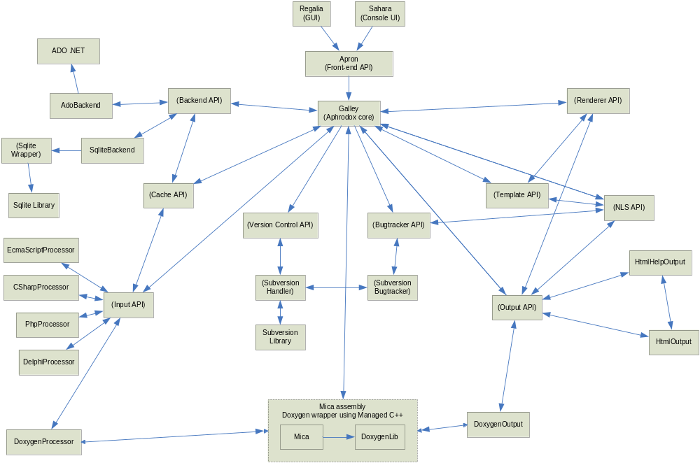

Decisions

Why Doxygen?
Simply put, it’s the only decent cross-platform, open source, multiple programming language documentation tool out there. phpDocumentor is very good for PHP, but it runs on PHP, and it’s almost dead.

Programming Language & Platform
C# for .NET. Why? It’s much easier than C++, has automatic garbage collection, not so slow, and almost cross-platform (there is Mono which runs on Linux, for example). Most importantly, it works also with native C/C++ [unmanaged] code.
Java? I like C# better, and it’s easier to work with C/C++ code using C# than using Java. I also like using properties than using explicitly named getter/setter methods, ugly.
Note that some parts of Aphrodox (especially Plastic, the Doxygen wrapper) needs to be written in C++ using Managed Extensions for performance. Note that Plastic is linked statically with Doxygen so even the Doxygen code runs in CLR.

Plastic
This is a big problem. Doxygen is written in C++, and is using other libraries such as Qt. Even if we compile Doxygen in CLR (with a lot of trouble), it still uses other native libraries (which means expensive marshalling). So? I think making a native DLL C++ wrapper (Mica? Or reverse Mica and Plastic?) for Doxygen is better, then call this DLL using marshalling. It’s still slower, but it’s much less work.

Milestones

Startup
- Making this executive summary.
- Making project skeleton.
- Creating Subversion repository for Doxygen trunk and first imported Doxygen version. Cleaning up CVS stuff.
- Importing Doxygen into Aphrodox project.
- Building Doxygen.
- Building Doxygen using VS .NET 2003.
- Creating DoxygenLib.
- Creating initial Mica: displays usage information.
- Creating initial Sahara (Aphrodox console): calls Mica to display usage information.
- Mica: generates documentation for a defined Doxygen file (PHP project).
- Update Sahara.
- Mica: generates documentation for parameter-specified Doxygen file.
- Update Sahara.

Learning Doxygen
- Tweak HTML output a bit to see how output template works.
- Tweak PHP input a bit (recognize implicitly named parameters in function documentation) to learn how input works. Request::GetForm.
- Tweak PHP input a bit (recognize bool/mixed/anything in return). Request::GetForm.

Some Things to Note
- doxygen.cpp:parseInput() does what it says (assembles a model)
  - Note: call setTranslator() first, otherwise it’ll die
  - readFiles() preprocesses all input files, standardizes comments (convertCppComments), then writes ALL FILES it to scratch file (marking each file contents with a header)
    - commentcnv.l:convertCppComments():
      - Converts multi-line C++ style comment blocks (that are aligned) to C style comment blocks (if MULTILINE_CPP_IS_BRIEF is set to NO).
      - It replaces aliases with their definition (see ALIASES)
      - It handles conditional sections (\cond...\endcond blocks)
  - scanner.l:parseMain() does the rough job of parsing stuff to the model.
    - scanner.l:parseCompounds() [recursive] handles the details. By the time it got into this function, the {Entry *rt} (which can be root or any compound) is already parsed into compounds and documents (anything inside comments). Useful things in Entry: name.data(), doc, docLine, fileName, program (if isEmpty() then it’s a normal compund otherwise some kind of program file), num (number of child entries).
  - buildNamespaceList() and most other functions requires the file dictionary (and all other directories), otherwise it’ll die
- generateOutput() does what it says. Actually the documentation is also parsed during output.
  - parseDoc() handles documentation parsing during output, which is tailored to whatever output is active
    - It calls validatingParseDoc() which (surprise!) parses the documentation inline
- It’s kind of pity Doxygen uses [commented] printf’s to display useful debugging messages. It’d be great if it uses some kind of logging class or at least #ifdef’s.

Other Uses
  - Subversion buddy (a must)
  - UML Generator (needed)
  - Syntax Highlighter
  - Code Reformatting Tool
  - Syntax checker (useful for PHP/interpreted languages)

Principles
- [Very] easy to use. Sahara is completely accessible using only command line (even ‘aphrodox .’ works). Regalia looks like InnoSetup wizard (which one?), or maybe Windows Explorer, or maybe VS.NET’s Solution Explorer.
- “Always successful”. All warnings will still generate (even unusable) documentation. An error has to be very fatal as to stop documentation (a parse error will ignore a file, not completely stop generation process).
- Visually pleasant. All output is beautiful.
- Solutions (Project Groups) and Projects:
  - [proposal 1] A documentation solution is composed of several projects. Each project can contain multiple programming languages (for example, mixing C# and VB.NET files is okay). Between projects there are no tight relationship except they are accessible in the same solution.
  - [proposal 2] A documentation solution can be composed of multiple programming languages and projects, however they’re treated globally. For example, class Human in Project A and class Animal in Project B belongs in the same symbol table. This is weird if you’re mixing unrelated languages, like PHP and JavaScript.
  - [proposal 3] A project property: treat elements as global. If this is true, all elements in all languages will be globalized. If this is false (default?), elements will be grouped by language. So you can have multiple subprojects within one documentation project that contain different languages without confusion. However, this needs grouping of table of contents by language.

Term Definitions (Literally)
Here are the reasons behind the names of Aphrodox components (definitions taken from WordWeb dictionary):
- Aphrodisiac. (noun) A drug or other agent that stimulates sexual desire. (adjective) Exciting sexual desire.
- Aphrodite. Goddess of love and beauty and daughter of Zeus in ancient mythology; identified with Roman Venus.
- Mica. Any of various minerals consisting of hydrous silicates of aluminum or potassium etc. that crystallize in forms that allow perfect cleavage into very thin leaves; used as dielectrics because of their resistance to electricity.
- Cram.
- Crowd or pack to capacity
- Put something somewhere so that the space is completely filled
- Eat until one is sated
- Study intensively, as before an exam
- Prepare (students) hastily for an impending exam
- Galley
- A large medieval vessel with a single deck propelled by sails and oars with guns at stern and prow; a complement of 1,000 men; used mainly in the Mediterranean for war and trading
- (classical antiquity) a crescent-shaped seagoing vessel propelled by oars
- The kitchen area for food preparation on an airliner
- The area for food preparation on a ship
- Sahara. The world's largest desert (3,500,000 square miles) in North Africa
- Regalia
- Paraphernalia indicative of royalty (or other high office).
- Especially fine or decorative clothing
- Bijou
- (noun) A small and delicately worked piece
- (adjective) Small and elegant
- Foundry. Factory where metal castings are produced. (chosen to avoid “Builder” or “Factory” so it’s not confused with design patterns, avoid “Generator” which is actually a “Director” which coordinates output processing, avoid “Flavor” which are different variations of “Themes”, avoid “Converter” [phpDocumentor term] which seem to convert one thing to another type [which it is not]).
- Meadow (pending). From “Bunglon – Come”. A field where grass or alfalfa are grown to be made into hay.

